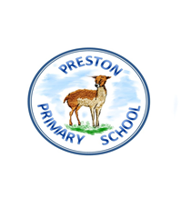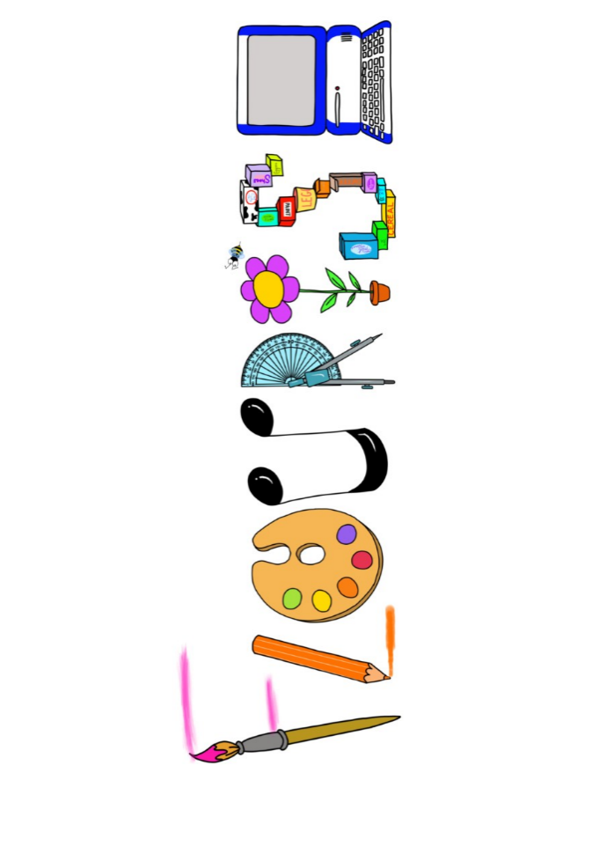 **at home.**

Kingfishers use your FLOURISH skills at home to create a masterpiece of your learning. Choose one task from the grid below.

|  |  |  |
| --- | --- | --- |
| **Term 3: Were the ancient Egyptians achievers?** | | |
| **I enjoy writing creatively** | Create an explanation of how a shaduf works. | Write a survival story set in ancient Egypt. |
| **I enjoy learning about the world(geography, history, RE, languages)** | Compare the ancient pyramids to another wonder of the world? | Compare the British social system to the ancient Egyptian social hierarchy. |
| **I enjoy using technology** | Create a powerpoint presentation to showcase your knowledge on ancient Egypt. | Create a documentary on what you think life was like in ancient Egypt. Use the horrible histories book to share some interesting facts as evidence. |
| **I enjoy being creative** | Use colour and texture to recreate a portrait of a god. | Create a piece of ancient Egyptian jewellery. |
| **I enjoy being practical** | Make a model of the pyramids. | Write a song inspired by the ancient Egyptians and maybe perform. |

Your FLOURISH at home needs to be in school the week beginning **Monday 10th February 2025**. It will be shared☺ and celebrated☺.

Happy Creating ☺