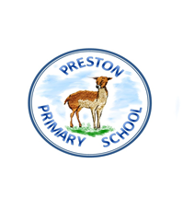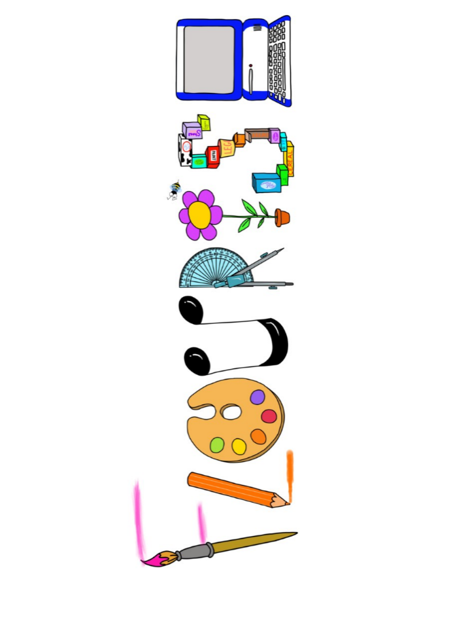 **at home.**

Kingfishers use your FLOURISH skills at home to create a masterpiece of your learning. Choose one task from the grid below.

|  |  |  |
| --- | --- | --- |
| **Term 4: Were the ancient Egyptians achievers?** | | |
| **I enjoy writing creatively** | Write an adventure story based on survival. | Create a travel brochure for all the best places to visit in Egypt. |
| **I enjoy learning about the world(geography, history, RE, languages)** | Create a fact file on Tutankhamun. | Create a fully labelled model of a river from its source. |
| **I enjoy using technology** | Create a powerpoint presentation to show why you think the Egyptian were achievers. | Create an interactive game using scratch about what you know about the Egyptians. |
| **I enjoy being creative** | Design your own Egyptian god or goddess. | Make a sarcophagus mask. |
| **I enjoy being practical** | Make some kahk (Egyptian Eid cookies). | Make an ancient Egyptian amulet out of salt dough |

Your FLOURISH at home needs to be in school the week beginning **Monday 31st March 2025.**It will be shared☺ and celebrated☺.

Happy Creating ☺