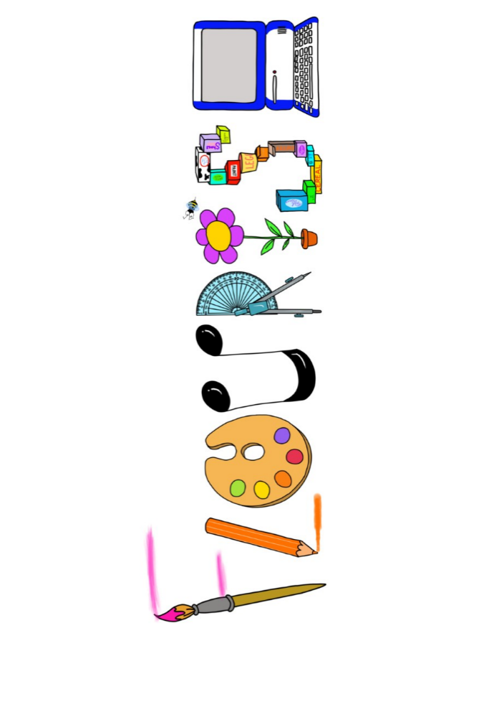 **at home.**

Kingfishers use your FLOURISH skills at home to create a masterpiece of your learning. Choose one task from the grid below.

|  |  |  |
| --- | --- | --- |
| **Term 5- Evolution- Where are we going?** | | |
| **I enjoy writing creatively** | Write a speech in the role of the Prime Minister about your intention to legalise graffiti. | Write a diary entry in role as Charles Darwin about a discovery you have made. |
| **I enjoy learning about the world(geography, history, RE, languages)** | Compare 2 different creation myths from around the world. | Compare the work of a US pop artist and a British pop artist from the 1960s. |
| **I enjoy using technology** | Create your own black and white portrait using technology. | Create your own graffiti tag and use it to make a piece of graffiti on.  [www.graffiti-empire.com/graffiti-generator/](http://www.graffiti-empire.com/graffiti-generator/) |
| **I enjoy being creative** | Create a pop art collage about yourself. | Create your own Banksy style piece of graffiti. |
| **I enjoy being practical** | Find a popular British meal/pudding of the 1960s and make it. | Create your own pop song. (that you might here nowadays on the radio) |

Your FLOURISH at home needs to be in school the week beginning **Monday 19th May**. It will be shared☺ and celebrated☺.

Happy Creating ☺