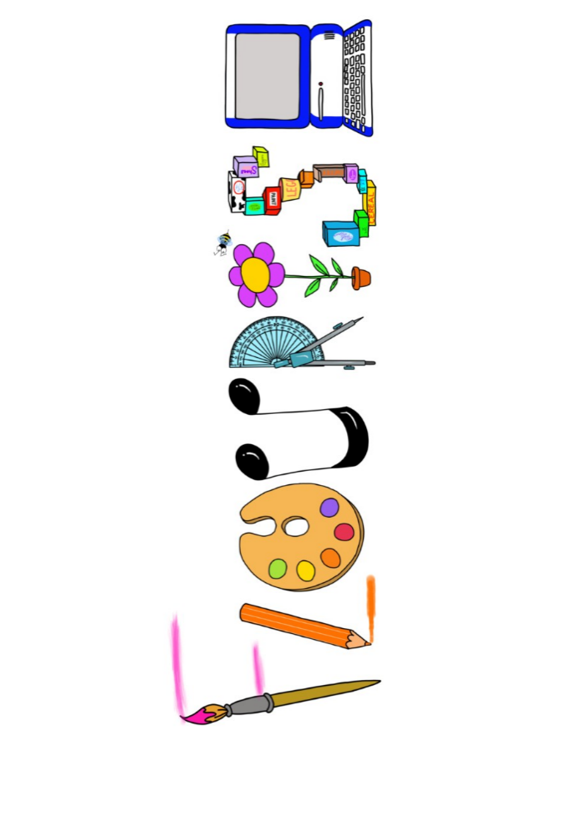 **at home.**

Kingfishers use your FLOURISH skills at home to create a masterpiece of your learning. Choose one task from the grid below.

|  |  |  |
| --- | --- | --- |
| **Term 1 How will I survive?** | | |
| **I enjoy writing creatively** | Create a manual for survival. | Create your own island setting description. |
| **I enjoy learning about the world(geography, history, RE, languages)** | Create your own theory about the demise of the Mayan civilisation. | You are a tour guide at Chichen Itza. What would be your top 5 sites to take your tour group to and why? What would you tell them? |
| **I enjoy using technology** | Use scratch to design an island survival game. (Google scratch)  <http://scratch-kids.en.softonic.com> | Create a video news report about Michael’s disappearance. |
| **I enjoy being creative** | Design your own Mayan head dress in the style of a Mayan god or goddess. | Create your own artwork inspired by Jerry Clovis |
| **I enjoy being practical** | Create an animal trapping device. | Design and build an island that you could live on. |

Your FLOURISH at home needs to be in school the week beginning **Monday 21st October 2024.** It will be shared☺ and celebrated☺.

Happy Creating ☺