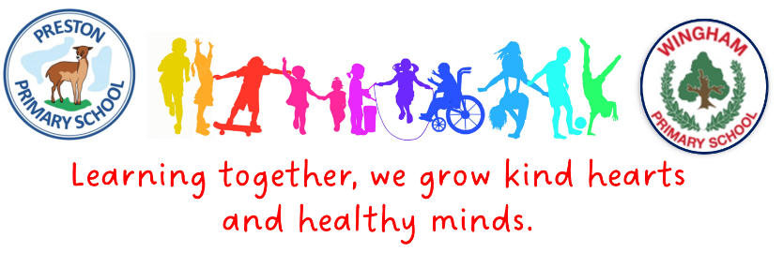

**Statement of Intent for English**

**Intent**

At the Preston and Wingham School Federation we ensure that our English curriculum develops pupils’ love of reading, writing and discussion, through our carefully planned cross-curricular units. The teaching of English is an intrinsic part of this cross-curricular approach and each text has been chosen to complement the themes so that reading comprehension and writing skills are developed through them. Whilst reading and writing skills are taught through the chosen topics and texts wherever possible, it is necessary to teach some aspects discretely.

**Implementation**

**The writing journey -** Throughout the writing journey, we teach children new and innovate vocabulary and start off with a make element (drama, role play, music, art) to inspire their writing. Editing is a very important part of the journey and children are taught to draft and redraft their work before presenting their final pieces.

**Grammar, punctuation and spelling** will be taught in line with the national curriculum, building on the phonics teaching.

We follow the **No Nonsense Spelling programme** to provide structure to the teaching of spelling. It fits with our ethos/ approach to learning. It helps to support our learners to become better spellers. We have adopted some elements of the programme to align with our beliefs. For example, we do not implement the ‘test’ aspect but rather assess according to how well children apply the spelling rules they have been taught in their written work.

**Phonics -**  In the foundation stage and key stage 1 we teach phonics through the Read, Write, Inc Ruth Miskin phonics program at Preston Primary and through Twinkl Phonics at Wingham Primary. Both programmes are a systematic, fast paced approach to teaching phonics. The children read decodable books that match their phonics level. This progresses into year 3 where phonics knowledge continues to underpin the teaching of spelling.

**Reading** - We follow a whole class reading approach where teachers model reading skills using the same text for the class which is pitched at ARE or just above. We follow a weekly plan in all classes that looks at vocabulary in the beginning of the week and ends with pupils answering questions about the text. (See Appendix 1) We have bespoke personalised avatars to support the teaching of reading skills in reading lessons. The children develop and build upon their knowledge of the following key skills:

**Key stage 1:**

* word meaning
* retrieval
* sequences
* inference
* prediction

**Key stage 2:**

* word meaning
* retrieval
* summarising
* inference
* prediction
* relationship
* word choice
* comparison

**Handwriting** – The majority of pupils learn to join their handwriting in year 2 though this is delayed or revised in lower key stage 2 if necessary. Presentation skills, including those that are computer-generated are an important part of children’s learning across the school.

Cross Curricular Reading and writing is taught across the curriculum ensuring that skills taught in these lessons are applied in other subjects.

**Impact**

By the time the children leave Preston & Wingham Federation we expect children to have:

Achieved Age Related Expectations (ARE) for their year group.

Some children will have progressed further and achieved greater depth (GD). Pupils falling into the lowest 20% category make progress from their starting point and as with all pupils are proud of the progress they have made.

As a result of our approach to English teaching, pupils will develop a range of skills that will enable them to succeed academically, personally, and professionally in later life. There will be significant improvements in pupils' reading fluency, stamina, comprehension, vocabulary, and critical thinking skills. The quality and range of pupils' writing will also improve, as will their confidence in expressing themselves orally and in writing. Finally, our approach to English teaching will encourage pupils to develop a lifelong love of reading and writing, which will positively impact their personal wellbeing, cultural capital, and future aspirations.