Progression in the teaching of calculation

This document has been produced in line with the Primary National Curriculum for mathematics and the White Rose MathsHUBS Calculation Policy in order to help you in supporting your child in mathematics.
5 + 1 = 6
5 + 2 = 7
5 + 3 = ?

Here at the Preston and Wingham Primary Schools Federation, we believe that in order for children to become confident, curious and resilient mathematicians, maths should be fun and engaging for learners of all ages by creating as many opportunities as possible to make links not only with other areas of maths and the wider school curriculum, but also in learners’ everyday experiences away from school. This might, for example, be while playing at home with their toys and sorting or counting objects; going to the shops with a grown up and spending money; or looking at shapes and patterns both in nature and in manmade structures in the town centre. In this way, we hope that the use of mathematics will gradually become second nature to the children and will form part of their daily experiences in the same way that speaking and listening does.

By teaching in stages and showing them a variety of ways to calculate, we encourage children to identify patterns and make connections so we can ensure that they really understand what they are doing rather than just following a set of instructions. As part of our teaching, we use the idea of ‘variation’ in both a child’s conceptual, and procedural, understanding. The use of both ‘standard’ and ‘non-standard’ examples is a key feature of this approach as this enables children to fully understand the features of something like, say, a triangle. The use of ‘non-examples’ is also a key feature of the teaching of mathematics as it helps children of all ages identify why something is, say, a triangle and why something else is not thus developing, and promoting use of, learners’ reasoning skills which in turn has a direct impact on their problem solving ability.

What you need to know about calculations

Mathematics will be at the core of your child’s schooling from the moment they start to the moment they leave. They will be involved in drawing, measuring, handling data and lots of other practical activities that will help your child to understand and enjoy the subject. The methods we are advocating follow the White Rose MathsHUBS programme of study and are in line with the National Curriculum (September 2014).

The methods we use in school may or may not be familiar to you. Children are often confused when they ask parents for help at home and parents try to teach them the methods that they themselves were once taught. Knowing how the methods in this document work will help you to help your child. All staff members in school work from this document so that we can ensure consistency of our approach and can make sure that the children move onto the next step when they are ready.

The 4 operations covered in this leaflet are addition, subtraction, multiplication and division. Whichever operation is being taught, the child needs to experience all of the following steps (known as CPA) to fully master it:

- Concrete – using physical objects/resources such as counters, Base 10, Numicon, etc. to represent numbers
- Pictorial – drawing a picture/diagram which represents the physical resources previously used to represent numbers
- Abstract – solving problems using only numbers

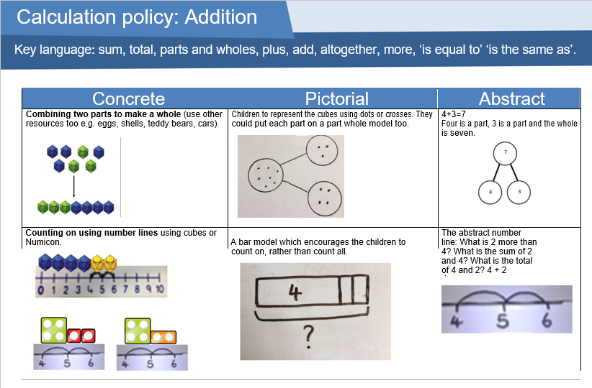
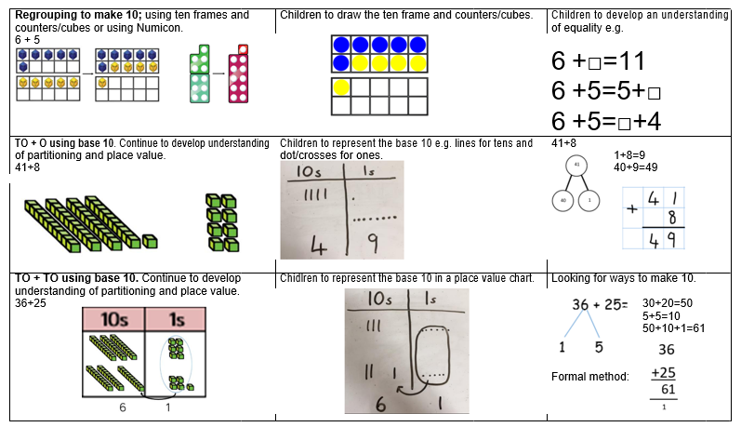
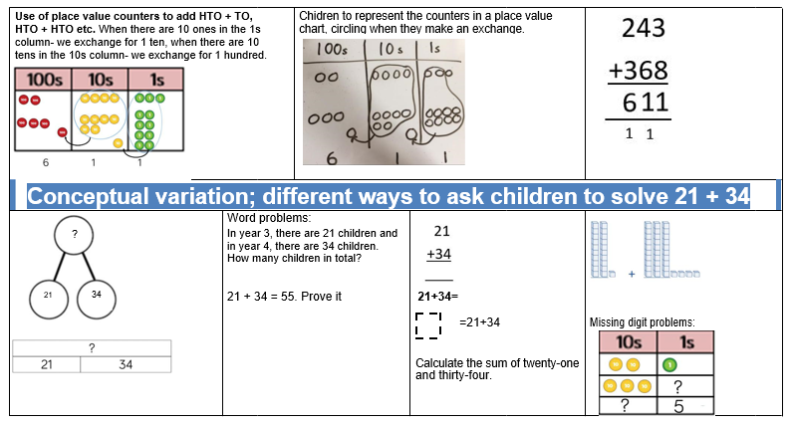

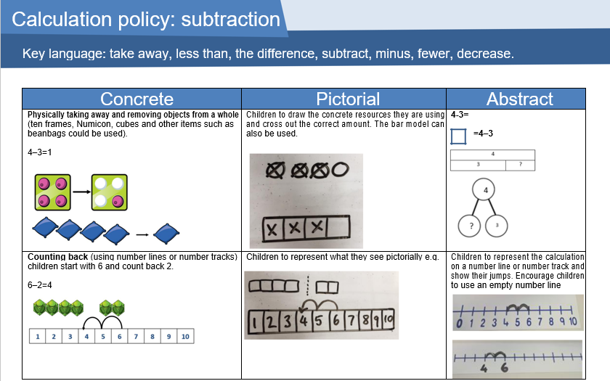
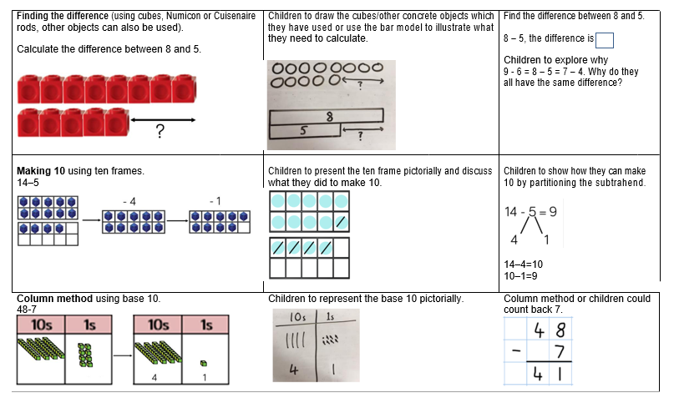
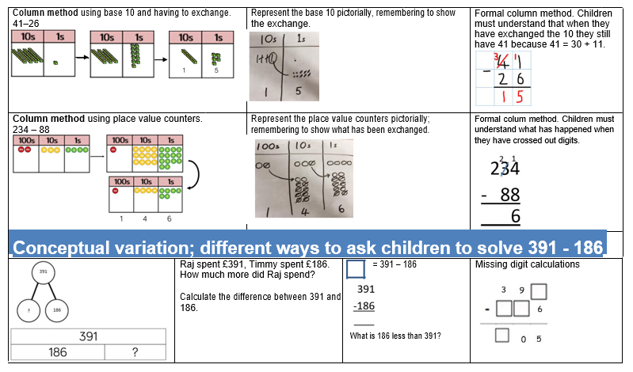
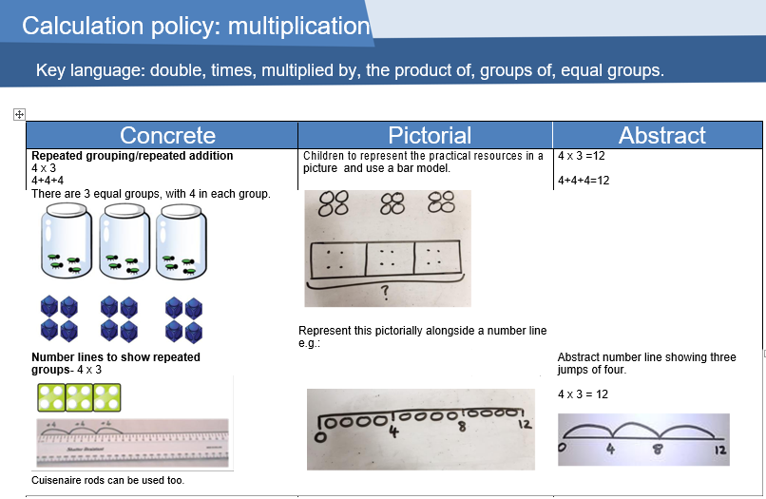
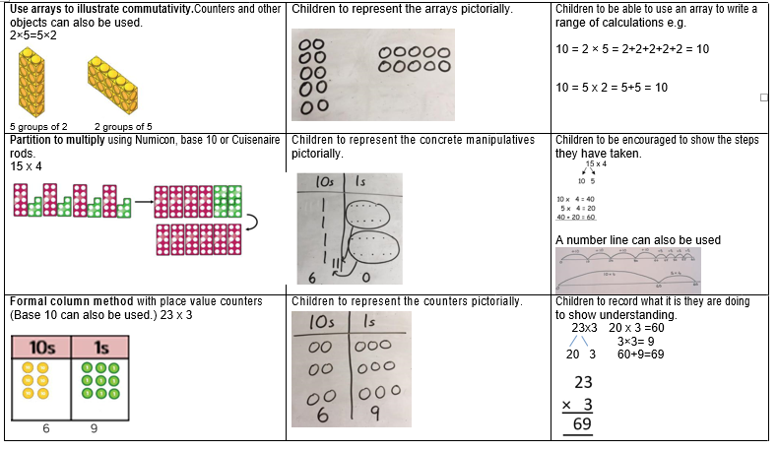
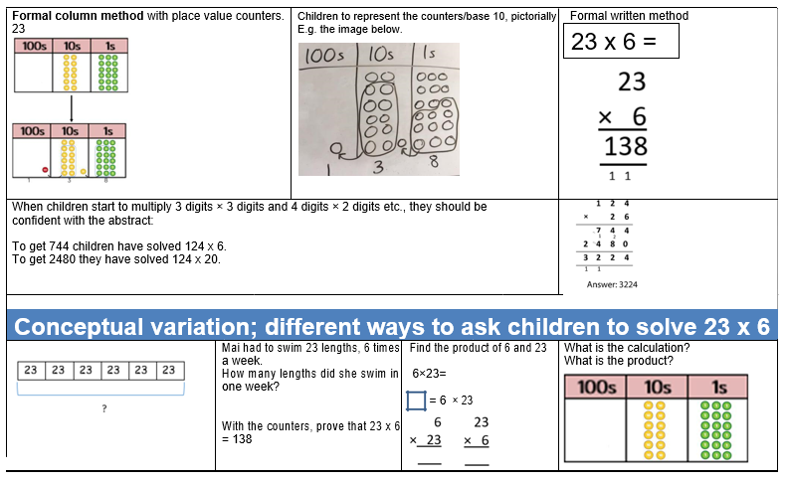
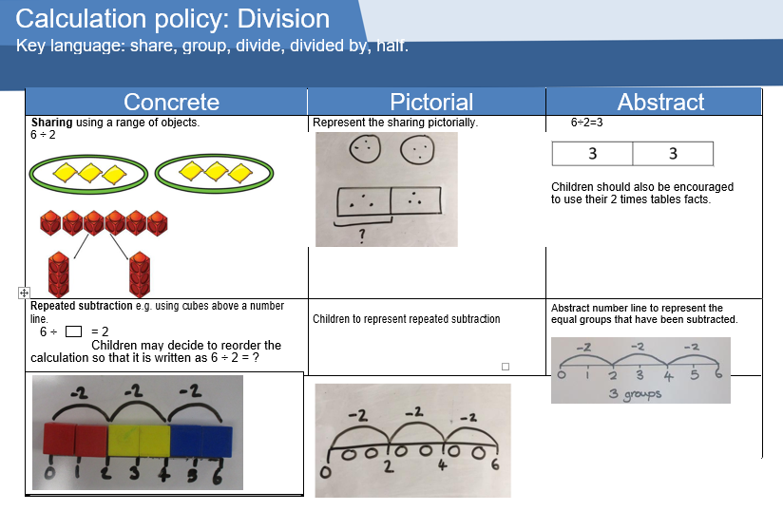
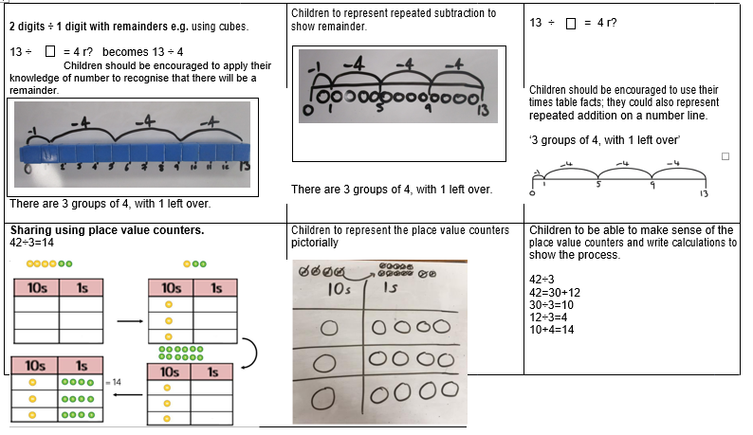
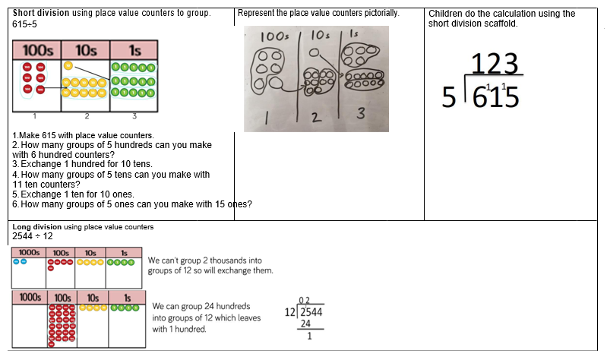
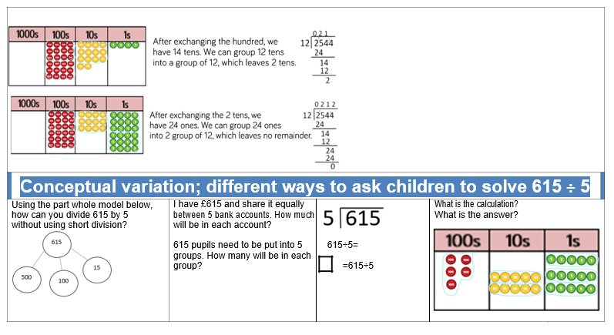
Glossary

Term | Definition | Examples
2 digit | a number made up of 2 digits | 23, 48, 59, 12
3 digit | a number made up of 3 digits | 213, 504, 897
Addend | the numbers being added together to form a sum | 51 + 182
Array | an arrangement of a set of numbers or objects in rows and columns | 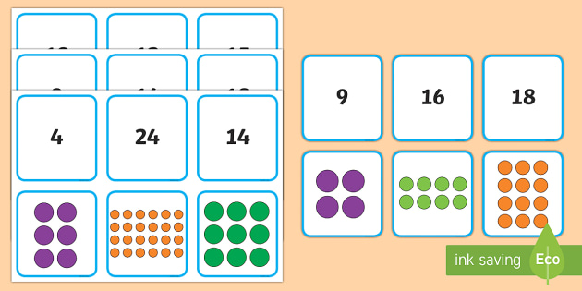
Bridge to ten | a strategy when using number lines. Adding a number that takes you to the next tens number
Bus Stop Method | a traditional method for division with a single digit divisor
Column Chunking | method of division involving taking chunks or groups or the divisor away from the larger number
Commutative law | addition and multiplication are both ‘commutative’. With addition, numbers can be added in any order and the result will always be the same. The same applies for multiplication. | Addition: 6 + 3 + 5 = 5 + 6 + 3  Multiplication: 2 x 4 x 3 = 4 x 3 x 2 = 3 x 4 x 2
Conceptual variation | use of examples and ‘non-examples’ (e.g. a triangle) to help learners understand what is correct and what is not; use of standard and non-standard examples (e.g. pictorial representations of a quarter) | 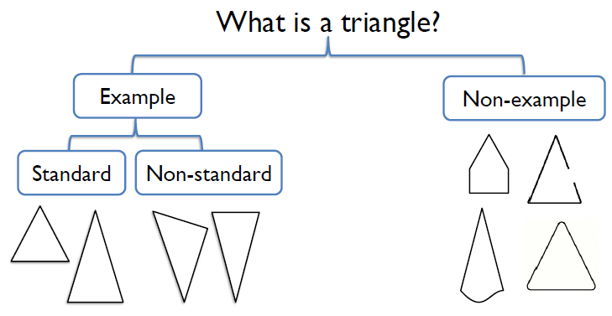
Decimal number | a number with a decimal point | 3.8, 52.04, 9.866
Difference | the amount by which one number or quantity is more or less than another. It is found by subtracting one quantity from the other
Dividend | the number being split (or divided) up | 12 ÷ 6 where 12 is the dividend
Divisor | the amount of groups the dividend is being split into to leave a quotient | 12 ÷ 6 = 2 where 6 is the divisor
Double | multiply a number by 2 | Double 6 = 6 x 2
Exchanging | Moving a ‘ten’ or ‘hundred’ from its column into the next column and splitting it up into ten ‘ones’ (units) or ten ‘tens’ and putting into a different column
Find the difference | A method for subtraction involving counting up from the smaller to the larger number

Grid method | a method for multiplying two numbers together involving partitioning | 26 x 5  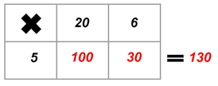
Half | a number or shape or quantity that is one of two equal parts of a whole
Halve | to divide a number by 2 (to split it into two equal parts) | To halve 18 = 18 ÷ 2
Integer | a number with no decimal point | 8, 2046, 39
Inverse | the opposite operation. Addition is the inverse of subtraction; multiplication is the inverse of division. | 18 + 4 = 22, so 22 – 4 = 18  It is commonly used in missing number problems:  15 + = 22 can be solved by doing 22 – 15 =  Here, the addition has been rewritten as a subtraction so the addend has become a subtrahend to be subtracted from the sum in order to find the missing number
Long multiplication | column multiplication where only the significant figures are noted
Multiplicand | the number that is being multiplied - could also be referred to as the amount in a group | ‘3 groups of 7’  7 is the multiplicand and 3 is the multiplier (7 x 3)
Multiplier | the number by which another number (multiplicand) is multiplied | 6 x 8 where a group of 6 is being multiplied by 8  (6 is the multiplicand; 8 is the multiplier)
Numberline chunking | method of division that involves taking chunks of the divisor away from the larger number (or dividend)
Number bonds to 10 | 2 numbers that add together to make ten, like 3 and 7, 8 and 2
Number bonds to 100 | 2 numbers that add together to make 100 like 20 and 80, or 45 and 65 or 12 and 88
Number sentences | writing out a calculation with just the numbers in a line | 2 + 4 = 6  21 ÷ 3 = 7
Operation | a mathematical process combining numbers through either + (addition), - (subtraction), x (multiplication) or ÷ (division) | 18 – 10 = 8  Here the subtraction operation is being used
Partition | to split up numbers with two or more digits into their constituent parts or even to split up smaller 1 digit numbers to help with certain calculations such as subtractions using the ‘part part whole’ model | 328 = 300 and 20 and 8  Part part whole example:  14 – 5 where 5 is split into 4 and 1 to become 14 – 4 = 10; then 10 – 1 = 9
Place value | knowing that in the number 342 the 3 means three hundreds, the 4 means four tens and the 2 means two units | 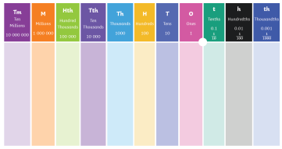  3  4  2
Procedural variation | making changes within a procedure leading to a different result in order to be able to identify patterns and make connections | 5+1=6  5+2=7  5+3=8 the second addend each time increases by 1, therefore the sum each time increases by 1  9 – 5 =  8 – 5 =  7 - 5 =  What’s stayed the same? What is different?
Quarter | a number or shape or quantity that is one of four equal parts of a whole | 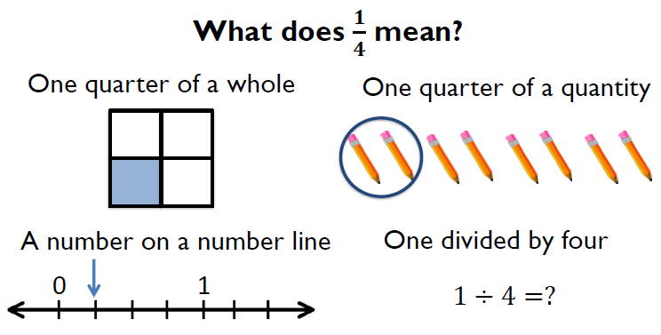
Quotient | the amount in each group after a dividend is divided by a divisor | ’12 ÷ 6 = 2’ where 2 is the quotient.  12 has been split into 6 equal groups with 2 in each group
Recombine | for addition, once you have partitioned numbers and added them separately you then add the answers together for the total | 62 + 34 becomes 60 + 30 = 90  2 + 4 = 6  Then 90 + 6 = 96
Remainder | a while number left over after division | 31 ÷ 4 = 7 r3  We can only count in 4s seven times, as far as 28, without going past 31. The difference between 28 and 31 is 3 which is left over and is therefore the remainder
Repeated addition | repeated adding groups of the same size for multiplication | 3 x 8 = 3 + 3 + 3 + 3 + 3 + 3 + 3 + 3

Subtrahend | a number being subtracted from another | 12 – 9 = 3, where 9 is the subtrahend
Sum | the result of two or more numbers (or addends) being added together | 24 + 15 = 39, where 39 is the sum

