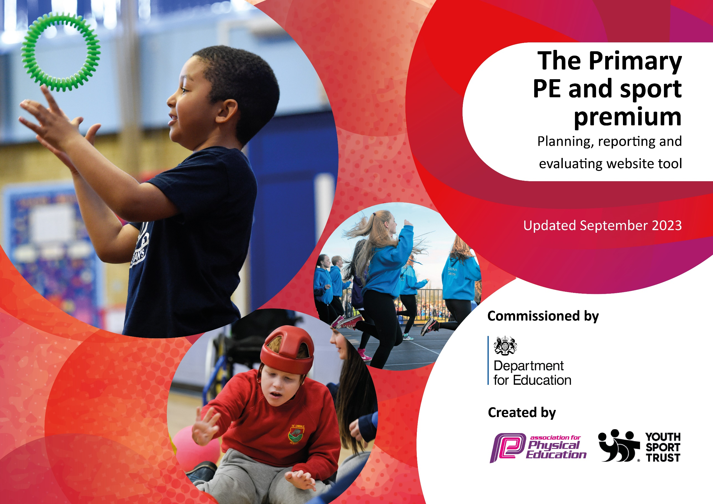

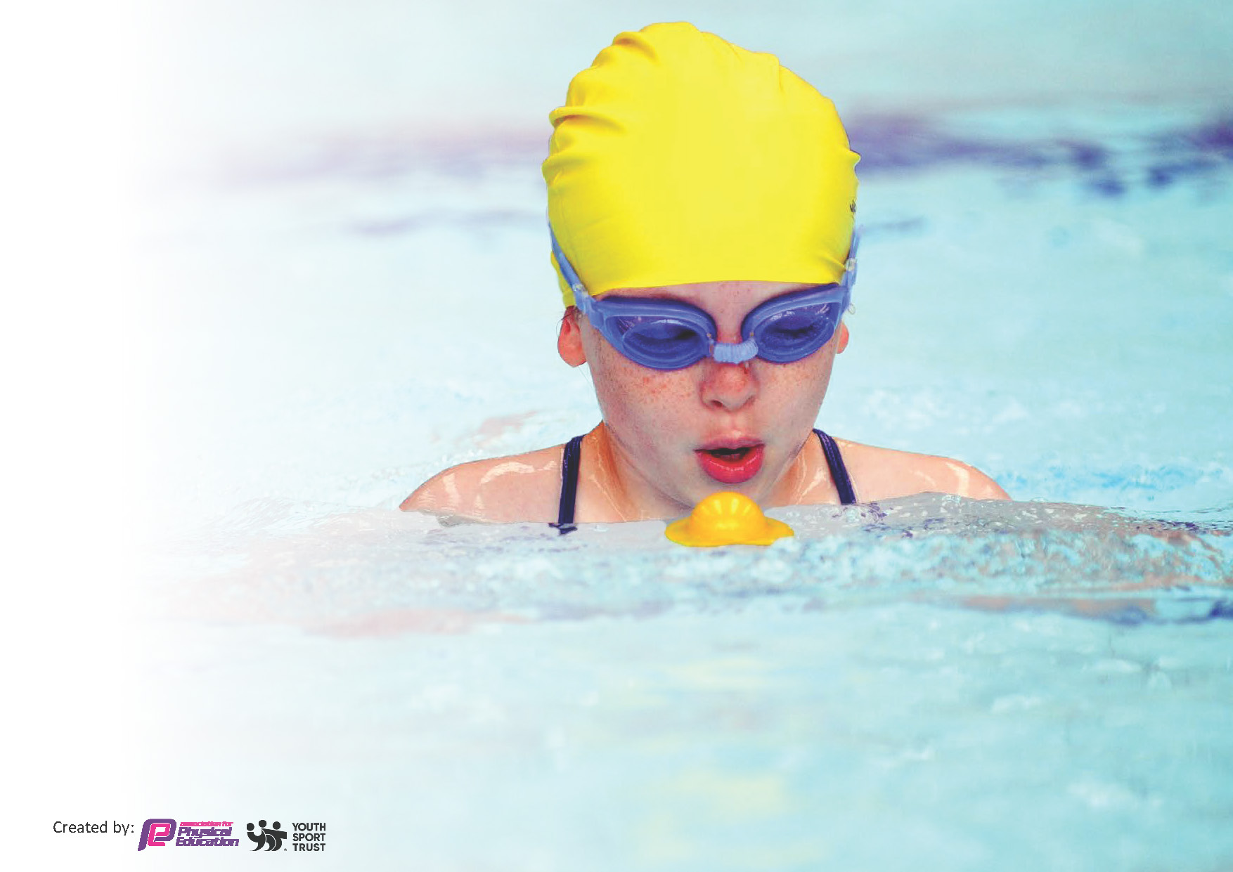
This template can be used for multiple purposes:
by:
- It enables schools to effectively plan their use of the Primary PE and sport premium
- It helps schools to meet the requirements (as set out in guidance) to publish information on their Primary PE and sport premium
- It will be an effective document to support Ofsted inspections enabling schools to evidence progress in Physical Education (PE) and evidence swimming attainment, which forms part of the PE National Curriculum. We would recommend schools consider
the Intent, Implementation and Impact of any spend, as examined within the Education Inspection Framework.

It is important that your grant is used effectively and based on school need.

Schools must use the funding to make additional and sustainable
improvements to the quality of the PE, School Sport and Physical Activity (PESSPA)
they offer. This means that you should use the Primary PE and sport premium to:

- Build capacity and capability within the school to ensure that improvements made now will benefit pupils joining the school in future years
- Develop or add to the PESSPA activities that your school already offers.

The Primary PE and sport premium should not be used to fund capital spend projects; the school’s core budget should fund these. Further detail on capital expenditure can be found in the updated Primary PE and sport premium guidance.

The Primary PE and sport premium guidance, outlines 5 key priorities that funding should be used towards. It is not

necessary that spending has to meet all the key priorities, you should select the priorities that you aim to use any funding towards.

Although completing this template is not a requirement for schools, schools are required to publish details of how they spend this funding. Schools must also outline what the impact this funding has had on pupils’ PE and sport participation and attainment and how any spending will be sustainable in the future. All funding must be spent by 31st July 2024.

The Department for Education has worked closely with the Association for Physical Education (afPE) and the Youth Sport Trust (YST) to develop this template and encourages schools to use it. This template is an effective way of meeting the reporting requirements of the Primary PE and sport premium.
Review of last year’s spend and key achievements (2022/2023)

We recommend you start by reflecting on the impact of current provision and reviewing your previous spend.

Activity/Action | Impact | Comments
- Develop playtimes and active play at playtimes  - Increase participation in sporting events outside of school  - Increase clubs at lunchtime run by the children  - Sports Week- signpost and include a range of sports | - Playtime has been more structured with different activities- from bat and ball to basketball and skipping. Less children not engaged in activity at playtimes.  - The school has increased its participation in sporting events significantly in the last two years. More children across the school given the opportunity to represent the school. Children given a range of different sports  - Year 5 and 6 children given responsibility for running a sports club. Cricket, football and gymnastics have been well attended and well thought out. Developed the children’s confidence and also leadership skills.  - Children were given opportunities to participate in new sports such as canoeing, indoor surfing and mini trampolining | - More physical activity at playtimes children playing alongside each other – cooperation and turn taking and sharing. Less rough play on the playground.  - Children liked receiving a ’caps’ band and were proud of their achievements- Indoor green bowling success won the tournament with children who did not think themselves as sportspeople. Mindful next year with the cost of transport and getting children to events may have an impact going forward.  - Clubs will continue to develop next year.  - Children have enjoyed learning about new sports including water safety and this has seen after school clubs filled with children. They especially enjoyed Quidditch and have requested this be a club going forward.

Key priorities and Planning
This planning template will allow schools to accurately plan their spending.

Action – what are you planning to do | Who does this action impact? | Key indicator to meet | Impacts and how sustainability will be achieved? | Cost linked to the action
Give children the opportunity to try new sports which they may not get to experience, skateboarding, climbing, archery, martial arts)  Giving children the opportunity to be active during break and lunch times as well as having appropriate equipment in lessons | Teachers – planning around the activities across the week  Pupils – exposure to new sports  Pupils – encouraging active and competitive play  Staff – ensuring children have use of the equipment and ensuring safety whilst doing so | Key indicator 4: Broader experience of a range of sports and activities offered to all pupils.  Key indicator 3: the profile of PE and sport is raised across the school as a tool for whole-school improvement  Key indicator 5: increased participation in competitive sport | More pupils meeting their daily physical activity goal, more pupils encouraged to take part in PE and Sport Activities.  More pupils are meeting physical requirements as well as exploring new activities and equipment in a safe environment. | £5000  £4500

Team Theme to deliver PE lessons, after school clubs  The PE curriculum is mapped out and sequenced effectively | Teachers – helping to improve their knowledge of activities as well as being able to assess more confidently (CPD)  Pupils – well-being of pupils being focused on  Teachers – Skills progression mapped out and PE assessment informs planning and support.  Pupils- Opportunities to build upon previous skills as they move through the school. | Key indicator 1: increased confidence, knowledge and skills of all staff in teaching PE and sport  Key Indicator 2: the engagement of all pupils in regular physical exercise  As above | Children given a range of sporting activities to support with their mental and physical health  Children build upon previous learnt skills and apply them in game situations in a range of sports. | £7000  £1050

Swimming Data
Meeting National Curriculum requirements for swimming and water safety.
Priority should always be given to ensuring that pupils can perform safe self-rescue even if they do not fully meet the first two requirements of the National Curriculum programme of study

Question | Stats: | Further context  Relative to local challenges
What percentage of your current Year 6 cohort can swim competently, confidently and proficiently over a distance of at least 25 meters? | 94% | Use this text box to give further context behind the percentage.  e.g., 30% - we are struggling to get pool space due to our local pool closing so we have had to use a much smaller local school pool. We have had to limit the number of pupils attending swimming lessons during one term which means some pupils have attended fewer swimming lessons than others.
What percentage of your current Year 6 cohort can use a range of strokes effectively [for example, front crawl, backstroke, and breaststroke]? | 83% | Use this text box to give further context behind the percentage.  e.g., Even though your pupils may swim in another year please report on their attainment on leaving primary school at the end of the summer term 2024

What percentage of your current Year 6 cohort are able to perform safe self-rescue in different water-based situations? | 44% | Use this text box to give further context behind the percentage.
If your schools swimming data is below national expectation, you can choose to use the Primary PE and sport premium to provide additional top-up sessions for those pupils that did not meet National Curriculum  requirements after the completion of core lessons. Have you done this? | Yes/No | Children who could not swim were given the opportunity to have further lessons before leaving primary school. Some of the children did use these further lessons but some children did not want to.
Have you provided CPD to improve the knowledge and confidence of staff to be able to teach swimming and water safety? | Yes/No | Our children attend a different school for swimming lessons and this school provides qualified instructors as part of their package.

Signed off by:

Executive Head Teacher: | Helen Clements
Subject Leader or the individual responsible for the Primary PE and sport premium: | Phil Matthews
Governor: | Ed OConnor Chair of Governors
Date: | July 2024

