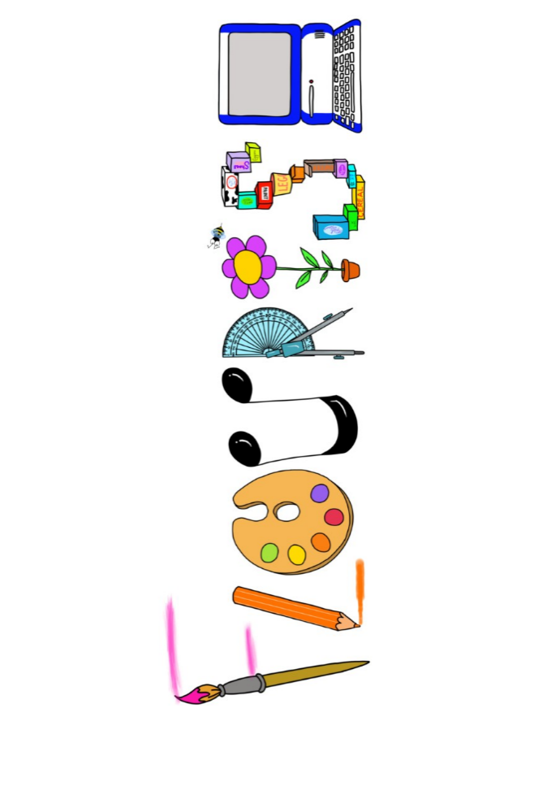 **at home.**

Use your FLOURISH skills at home to create a masterpiece of your learning. Choose one task from the grid below.

|  |  |  |
| --- | --- | --- |
| **Term 3: Are heroes worldwide?** | | |
| **I enjoy writing creatively** | Investigate a real-life hero of your choice from another country and record the information. (They don’t have to be famous) | Read an African traditional tale and re-write it in your own words. |
| **I enjoy learning about the world(geography, history, RE, languages)** | Can you look up a village in Africa and write about how it is different or the same to Preston. | Why is Africa a hot country? Research. |
| **I enjoy using technology** | Find a step-by-step African dance online and learn the moves. | Watch video clips of celebrations from different cultures. Record what you watched and learnt in any way you like. |
| **I enjoy being creative** | Create a superhero outfit. Design (and possibly create) a costume for your own superhero. This could be full-size or to fit a doll/teddy. | Look at examples of African art. Create your own picture. |
| **I enjoy being practical** | World War 2 pilots were real heroes. Build a model plane they might have flown. | Make a piece of African jewellery. |

Your FLOURISH at home needs to be in school the week beginning **Monday 10th February 2025.**  It will be shared☺ and celebrated☺.

Happy Creating ☺