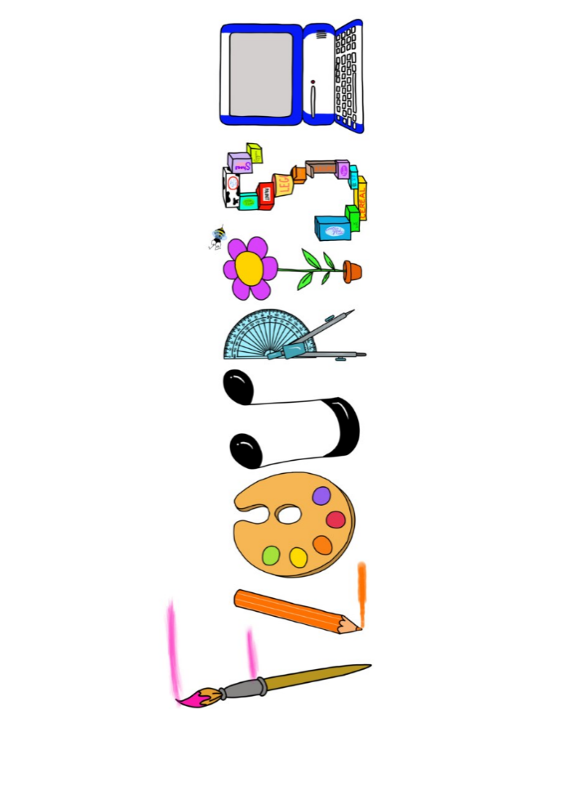 **at home.**

Hummingbirds use your FLOURISH skills at home to create a masterpiece of your learning. Choose one task from the grid below.

|  |  |  |
| --- | --- | --- |
| **Term 4: Who’s your hero?** | | |
| **I enjoy writing creatively** | Create a comic strip with a hero and a villain. | Write a story about your own superhero. |
| **I enjoy learning about the world(geography, history, RE, languages)** | Create a fact file about a well-known local hero or someone you would describe as your hero. | Make a list of all the heroes around the world- see how many you can find. |
| **I enjoy using technology** | Create a collage on the computer of your favourite heroes. | Dress up as a superhero and create a simple photo comic strip. |
| **I enjoy being creative** | Create a new costume for a superhero. | Draw and paint a picture of a superhero. |
| **I enjoy being practical** | Design a meal for a superhero. | Make a model of a supercar or plane that could be used by Batman or Batgirl. |

Your FLOURISH at home needs to be in school the week beginning **Monday 31st March 2024**. It will be shared☺ and celebrated☺.

Happy Creating ☺