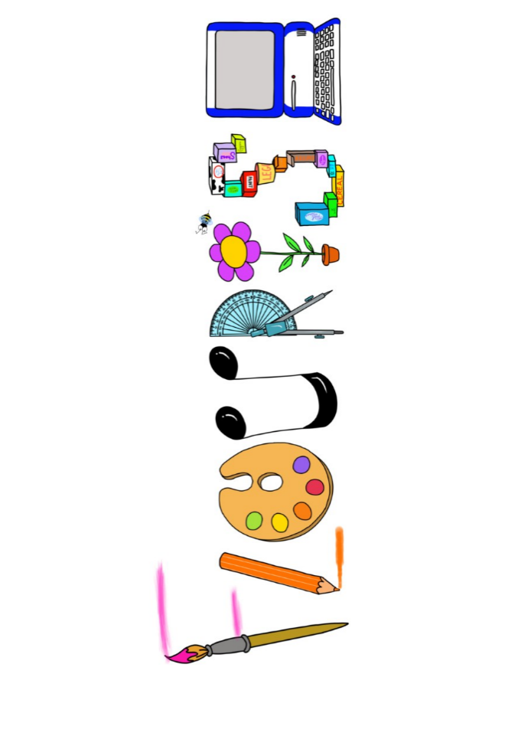 **at home.**

Hummingbirds use your FLOURISH skills at home to create a masterpiece of your learning. Choose one task from the grid below.

|  |  |  |
| --- | --- | --- |
| **Term 2: Could a dinosaur live in our village?** | | |
| **I enjoy writing creatively** | Create a dinosaur fact file on your favourite dinosaur. | Write a story a different ending to a story you have read in class. |
| **I enjoy learning about the world(geography, history, RE, languages)** | Locate on a map of Britain where fossils have been found? | Make a timeline of the dinosaurs. Include drawings if you can. |
| **I enjoy using technology** | Research Mary Anning and present how you like. | Visit the beach and take photos of any fossils you find. |
| **I enjoy being creative** | Invent your own dinosaur and paint a picture of it. | Create a pencil drawing of a fossil. |
| **I enjoy being practical** | Create a fossil using plasticine or clay. | Make a dinosaur out of junk model material. |

Your FLOURISH at home needs to be in school the week beginning **Monday 16th December 2024**. It will be shared☺ and celebrated☺.

Happy Creating ☺