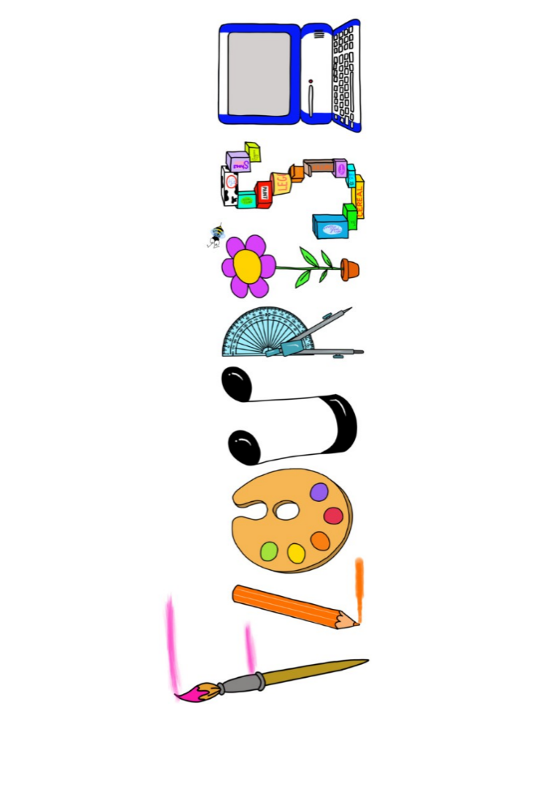 **at home.** Penguins use your FLOURISH skills at home to create a masterpiece of your learning. Choose one task from the grid below.

|  |  |  |
| --- | --- | --- |
| **Term 5 -Does it always rain in the rainforest?** | | |
| **I enjoy writing creatively** | Create your own rainforest animal poem. | Create a comic about your journey into the rainforest. |
| **I enjoy learning about the world(geography, history, RE, languages)** | Create a 3D globe showing where the rainforests are. | Research the Amazon river. Present your findings in your own way. |
| **I enjoy using technology** | Create a weather forecast video demonstrating the climate in the rainforest. | Design and create your own stop- motion animation. |
| **I enjoy being creative** | Create a model of the layers of the rainforest. | Paint a picture of the rainforest. Maybe use inspiration from one of the artists you have studied this year. |
| **I enjoy being practical** | What food would you find in the rainforest? Can you use them in a recipe? | Create a rain dance. |

Your FLOURISH at home needs to be in school the week beginning **Monday 19th May** . It will be shared☺ and celebrated☺.

Happy Creating ☺