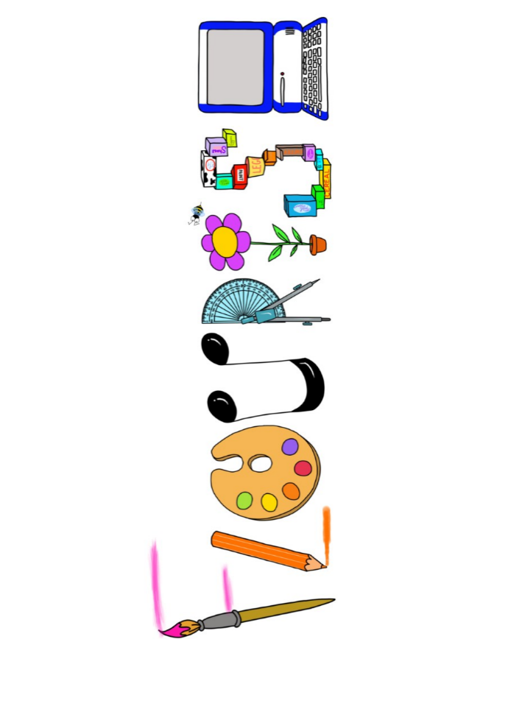 **at home.**

Kestrels use your FLOURISH skills at home to create a masterpiece of your learning. Choose one task from the grid below.

|  |  |  |
| --- | --- | --- |
| **Term 3: How would you protect your family?** | | |
| **I enjoy writing creatively** | Create a diary from the perspective of a soldier in World War 2. | Write your own 5 paragraph story based on a castle. |
| **I enjoy learning about the world(geography, history, RE, languages)** | Create a fact file on France- landmarks, culture, food. | Create a timeline (how you present it is your choice) of Kings and Queens from 1066 to 2023. |
| **I enjoy using technology** | Use effective searches and reliable sources to find how the local area has changed since 1066. | Use scratch to create a moving drawbridge on a castle. |
| **I enjoy being creative** | Draw and paint Dover castle. | Represent an experience story in the form of a tapestry, inspired by the Bayeux tapestry. |
| **I enjoy being practical** | Research and create different types of medieval food, recipes/dishes and perhaps make some. | Create your own puppet/model of a horse inspired by War Horse. |

Your FLOURISH at home needs to be in school the week beginning **Monday 10th February 202** . It will be shared☺ and celebrated☺.

Happy Creating ☺