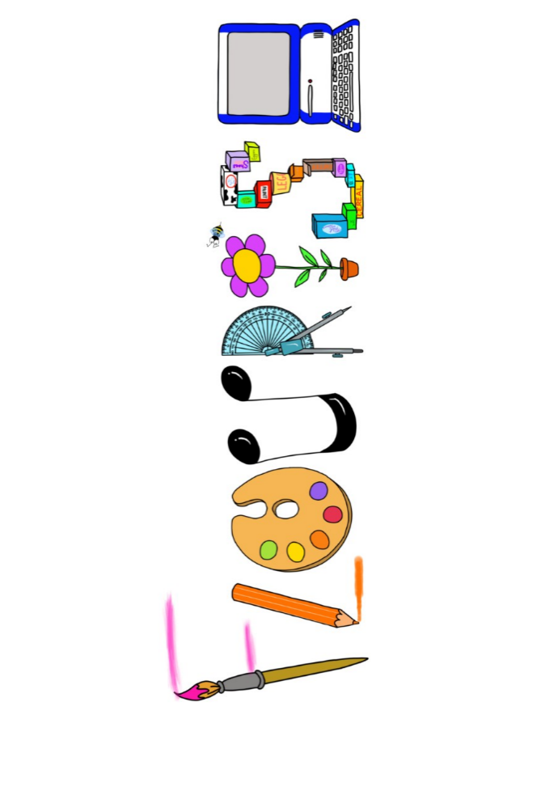 **at home.**

Kestrels use your FLOURISH skills at home to create a masterpiece of your learning. Choose one task from the grid below.

|  |  |  |
| --- | --- | --- |
| **Term 4: How would you protect your family?** | | |
| **I enjoy writing creatively** | Create a poster of one of the features of Dover Castle | Write a diary entry of one of the Norman soldiers at the Battle of Hastings. |
| **I enjoy learning about the world(geography, history, RE, languages)** | Research a town in France. Present your information however you wish | Can you create a French dictionary showing the words you have learnt so far? |
| **I enjoy using technology** | Take some landscape pictures and create a collage- similar to that of Turner. | Use scratch to create a moving drawbridge on a castle. |
| **I enjoy being creative** | Paint a picture in the style of Turner. | Create a model of Dover castle. |
| **I enjoy being practical** | Research and create different types of medieval food, recipes/dishes and perhaps make some. | Create your own puppet/model of a horse inspired by War Horse. |

Your FLOURISH at home needs to be in school the week beginning **Monday 31st March 2025** . It will be shared☺ and celebrated☺.

Happy Creating ☺