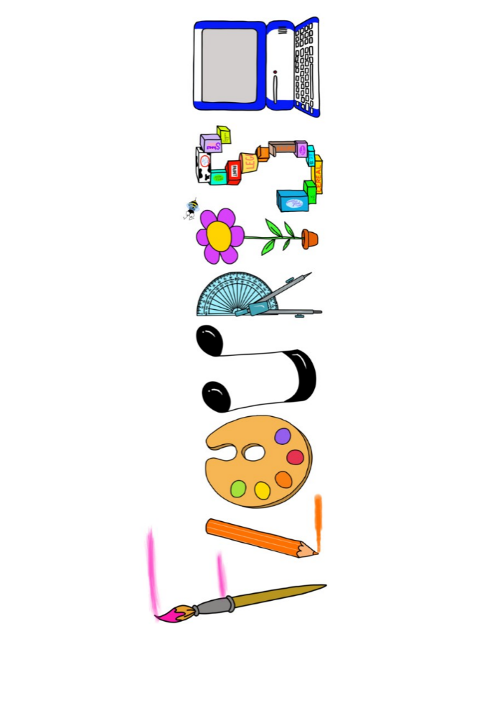 **at home.**

Kestrels use your FLOURISH skills at home to create a masterpiece of your learning. Choose one task from the grid below.

|  |  |  |
| --- | --- | --- |
| **Term 5 -What have the Romans ever done for us?** | | |
| **I enjoy writing creatively** | Create your own Roman hero story. | Create a pamphlet of a local Roman historical site, that will persuade me to visit (Reculver, Dover, Walmer, Deal or Rochester castle, the Roman House in Canterbury or the Richborough Roman Fort.) |
| **I enjoy learning about the world(geography, history, RE, languages)** | Research the legacy of the Roman Empire. What influences do we see today? | Where did the Roman Empire begin and how far did it spread? Can you find a way to show this (without just colouring in a map?) |
| **I enjoy using technology** | Use excel to create a mosaic. | Use sketch up to create a piece of Roman architecture. |
| **I enjoy being creative** | Create a Roman mosaic. | Create a Roman shield, decorated in a way that would intimidate your enemies. |
| **I enjoy being practical** | Explore, make and taste Roman food. | Create a game that teaches people about the Roman way of life. |

Your FLOURISH at home needs to be in school the week beginning **Monday 19th May** . It will be shared☺ and celebrated☺.

Happy Creating ☺