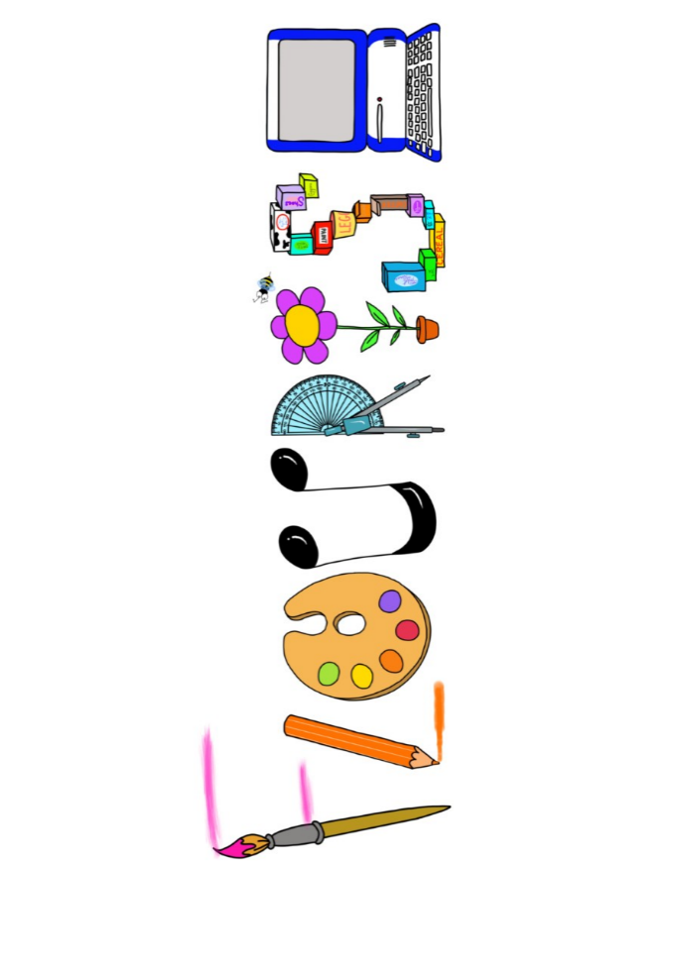 **at home.**

Kestrels use your FLOURISH skills at home to create a masterpiece of your learning. Choose one task from the grid below.

|  |  |  |
| --- | --- | --- |
| **Term 2: What would it feel like to be in space?** | | |
| **I enjoy writing creatively** | Write a story about a journey to space. Can you do it in 5 paragraphs? | Create either an acrostic or shape poem about space. |
| **I enjoy learning about the world(geography, history, RE, languages)** | Research a planet of your choice and present your findings. | Explain the Space Race- how creative can you be in showing your findings? |
| **I enjoy using technology** | Use scratch to create a rocket launch. | Make a photo diary of the moon over a period of time exploring differences in appearance. |
| **I enjoy being creative** | Create you own painting inspired the artist David Hardy. | Create a album cover for The Planets music by Holst. |
| **I enjoy being practical** | Use construction materials to make a rocket. | Create a model of the solar system. |

Your FLOURISH at home needs to be in school the week beginning **Monday 16th December 2024**. It will be shared☺ and celebrated☺.

Happy Creating ☺