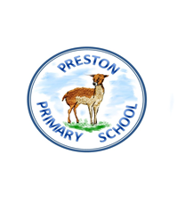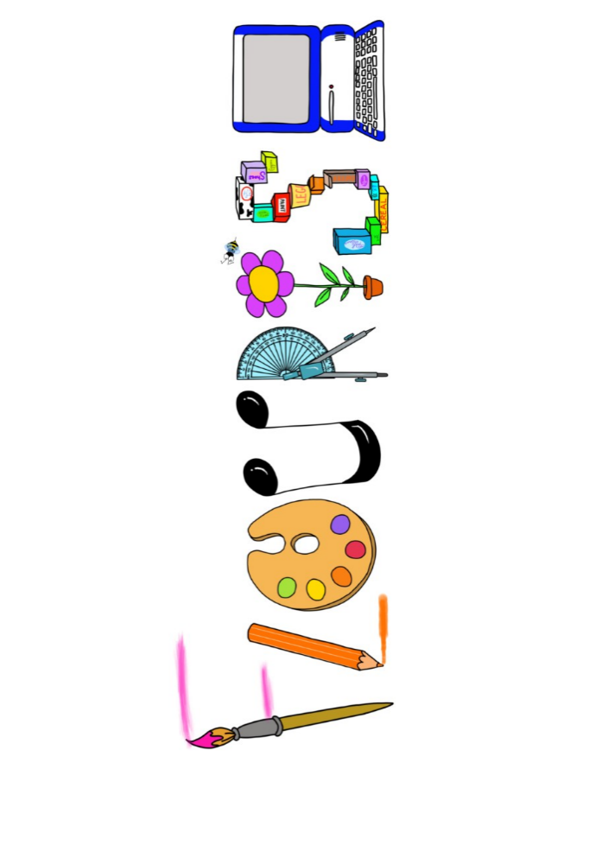 **at home.**

Kookaburras use your FLOURISH skills at home to create a masterpiece of your learning. Choose one task from the grid below.

|  |  |  |
| --- | --- | --- |
| **Term 3 : Are all stories true?** | | |
| **I enjoy writing creatively** | Retell a familiar fairy tale, i.e. make a book, create a comic strip. | Make your own book of one of the stories you liked learning about in class. |
| **I enjoy learning about the world(geography, history, RE, languages)** | Research the history of libraries – create a leaflet. | Learn key words from a fairy tale in another language. |
| **I enjoy using technology** | Retell your favourite fairy tell and video it so all can share in your story telling skills. | Create a video book review- reviewing a range of fairy tales |
| **I enjoy being creative** | Use pastels to draw a fairy tale picture. | Create your own princess or knight and paint a picture of them with their name. |
| **I enjoy being practical** | Make a treat for Little Red Riding Hood to take to Grandma. | Make a split-pin fairy tale character. |

Your FLOURISH at home needs to be in school the week beginning **Monday 10th February 2025**. It will be shared☺ and celebrated☺.

Happy Creating ☺