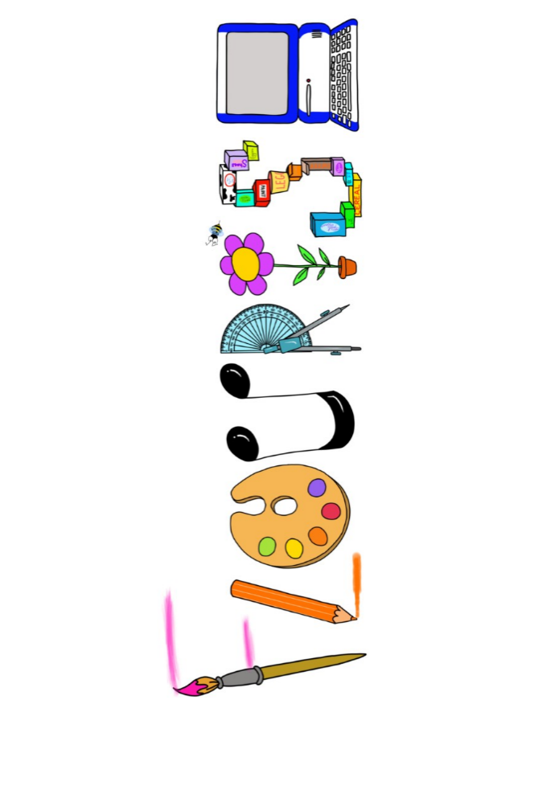 **at home.**

Kookaburras use your FLOURISH skills at home to create a masterpiece of your learning. Choose one task from the grid below.

|  |  |  |
| --- | --- | --- |
| **Term 4: Are all stories true?** | | |
| **I enjoy writing creatively** | Retell a familiar fairy tale, i.e. make a book, create a comic strip. | Make your own book of one of the stories you liked learning about in class. |
| **I enjoy learning about the world(geography, history, RE, languages)** | Research bears- where they life and different types of bears. Are there any bears in the UK? | Sing a simple nursery rhyme in French and get a grown up to record it. |
| **I enjoy using technology** | Use paint brush to create book cover for Goldilocks and the Three Bears. | Create a video book review- reviewing a range of fairy tales |
| **I enjoy being creative** | Paint a picture of a bear. It can be your favourite teddy bear, a polar bear, brown bear a grisly bear. | Create your own princess or knight and paint a picture of them with their name. |
| **I enjoy being practical** | Make some honey cakes or oat biscuits for a gift to say sorry to the 3 bears. | Make a chair or bed for Goldilocks to use when she visits the 3 bears house. |

Your FLOURISH at home needs to be in school the week beginning **Monday 31st March 2025**. It will be shared☺ and celebrated☺.

Happy Creating ☺