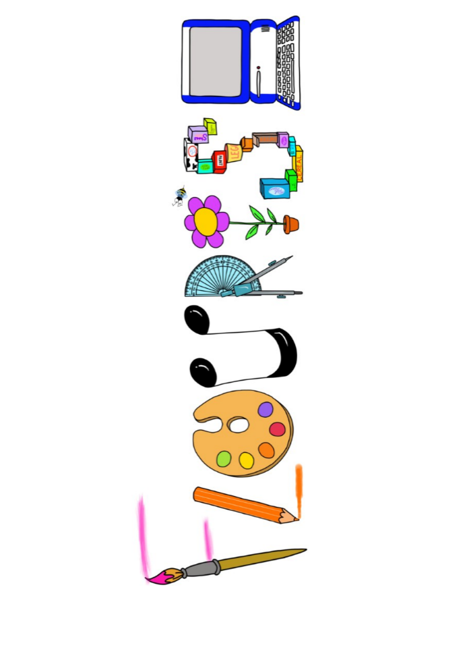 **at home.**

Penguins use your FLOURISH skills at home to create a masterpiece of your learning. Choose one task from the grid below.

|  |  |  |
| --- | --- | --- |
| **Term 3 : Would you be more scared of an Anglo Saxon or Viking?** | | |
| **I enjoy writing creatively** | Write a diary entry about the day in the life as an Anglo-Saxon child. | Create a fact file about the Anglo-Saxons. You can choose any aspect. |
| **I enjoy learning about the world(geography, history, RE, languages)** | Research about religion and Anglo-Saxon beliefs, gods and goddesses. | Create a presentation on the Battle of Hastings, where it was and what happened. You may want to use pictures. |
| **I enjoy using technology** | Research Sutton Hoo and create a power point | Create photo collage of Anglo-Saxon artefacts. |
| **I enjoy being creative** | Use clay or plasticine/playdough to create a stone carving. | Paint or draw a picture of an Anglo-Saxon village. |
| **I enjoy being practical** | Make some Anglo-Saxon bread. Can you make it in the same way? Will your bread be peasant or royal bread? | Design and make a shield for battle. |

Your FLOURISH at home needs to be in school the week beginning **Monday 10th February** 2025. It will be shared☺ and celebrated☺.

Happy Creating ☺