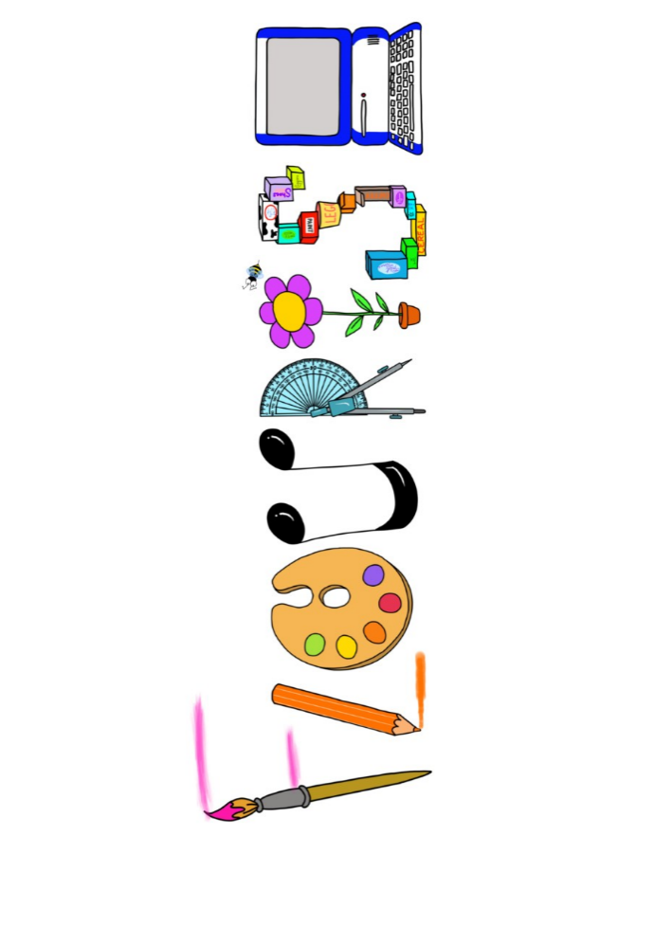 **at home.**

Penguins use your FLOURISH skills at home to create a masterpiece of your learning. Choose one task from the grid below.

|  |  |  |
| --- | --- | --- |
| **Term 4 : Would you be more scared of an Anglo Saxon or Viking?** | | |
| **I enjoy writing creatively** | Rewrite your version of the story of Beowulf. | Create your own horrible histories book on either the Anglo Saxons or the Vikings. |
| **I enjoy learning about the world(geography, history, RE, languages)** | Create a Viking hierarchy pyramid. | Research one of countries that the Vikings came from and present your findings. |
| **I enjoy using technology** | Use scratch to create an interactive game about Vikings or Anglo Saxons | Create a vlog. You are a Viking going to battle. |
| **I enjoy being creative** | Paint a picture of your own Viking. Is he or she fierce and menacing? | Make a model of a Viking longship. |
| **I enjoy being practical** | Make some Viking bread. Can you make it in the same way? | Use salt dough to make a piece of jewellery a Viking might have worn. |

Your FLOURISH at home needs to be in school the week beginning **Monday 31st March** 2025. It will be shared☺ and celebrated☺.

Happy Creating ☺