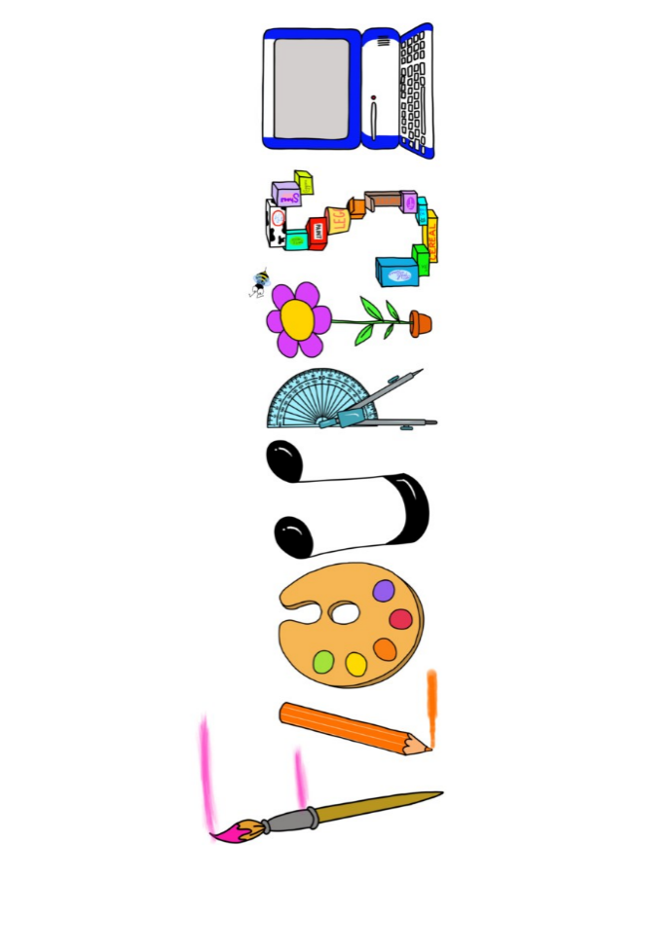 **at home.**

Kookaburras use your FLOURISH skills at home to create a masterpiece of your learning. Choose one task from the grid below.

|  |  |  |
| --- | --- | --- |
| **Term 5 Year 1 only -What lives in my garden?** | | |
| **I enjoy writing creatively** | Create your own picture book story about a minibeast( you may want to look some stories about minibeasts) | Draw and label a plant to include roots, stem, leaves and flower |
| **I enjoy learning about the world(geography, history, RE, languages)** | Research and record the names of familiar minibeasts in French. | Find out about the names of the parts of the plant and what each job and show us how you want what you have learnt. |
| **I enjoy using technology** | Photograph plants/ trees in your garden- name them and share some information about them | Go on a nature walk/bug hunt and photograph your findings. |
| **I enjoy being creative** | Use a collage technique to create a picture of a plant/tree/minibeast – in the style of Eric Carle  Look at Vincent Van Gogh’s sunflowers and paint your own version. | Gather natural resources and use to create a picture of your choice. |
| **I enjoy being practical** | Make a bug hotel. | Find out how honey is made and then make a honey cake – you could write the recipe too. |

Your FLOURISH at home needs to be in school the week beginning **Monday 19th May** . It will be shared☺ and celebrated☺.

Happy Creating ☺