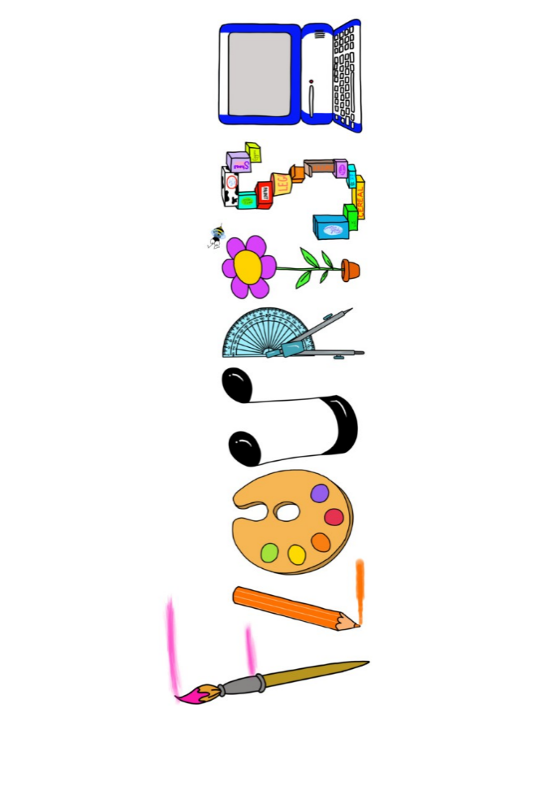 **at home.**

Hummingbirds use your FLOURISH skills at home to create a masterpiece of your learning. Choose one task from the grid below.

|  |  |  |
| --- | --- | --- |
| **Term 5 -What makes Britain great?** | | |
| **I enjoy writing creatively** | Imagine you went to visit the King in Buckingham Palace. Invite your family or toys for afternoon tea. Design and write the menu. | Write a fact file about a famous British author. |
| **I enjoy learning about the world(geography, history, RE, languages)** | Draw a map of one of the British capital cities. Don’t forget to include some of the famous landmarks. | Create a birthday card for someone in French. |
| **I enjoy using technology** | Film yourself giving a ‘virtual trip’ of a chosen place in the UK. Include pictures and facts. | Create a photo collage of famous landmarks. |
| **I enjoy being creative** | Create your own character and draw and paint it in the style of illustrator Quentin Blake. | Make a replica of a famous London landmark. You can use any medium e.g. Lego, Kinex, junk modelling, clay. |
| **I enjoy being practical** | Choose a British country and research what food they are well known for. Can you have a go at making some? | Find out which flowers are native to different countries in the UK. Can you make a collage of these flowers? |

Your FLOURISH at home needs to be in school the week beginning **Monday 19th May** . It will be shared☺ and celebrated☺.

Happy Creating ☺