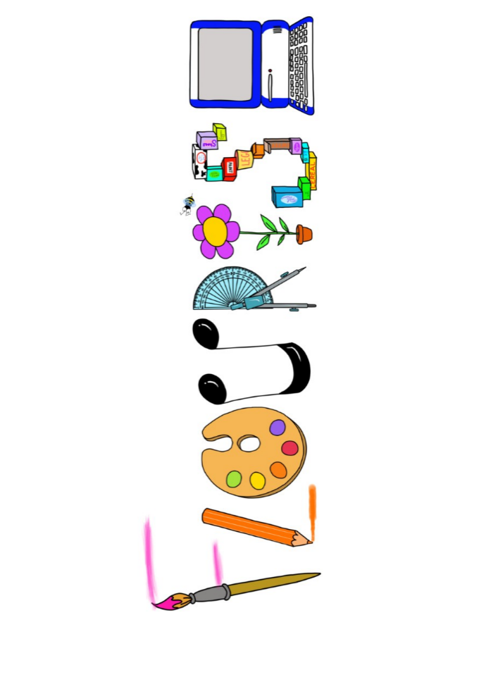 **at home.**

Kookaburras use your FLOURISH skills at home to create a masterpiece of your learning. Choose one task from the grid below.

|  |  |  |
| --- | --- | --- |
| **Term 1: What makes me special?** | | |
| **I enjoy writing creatively** | Make a book about your family. Can you include pictures and labels? | Draw and decorate your family tree. |
| **I enjoy learning about the world(geography, history, RE, languages)** | Find out about where you live? Can you draw your street or use google maps to print a picture? | Can you label the parts of the body in French? |
| **I enjoy using technology** | Take some family photos and arrange them to make a collage. | Use a paint programme to create a self-portrait. |
| **I enjoy being creative** | Paint a picture of your favourite toy. | Can you make Boris the Robot out of junk material? |
| **I enjoy being practical** | Make a model of your house with lego or construction materials. | Make a skeleton picture using only cotton buds. |

Your FLOURISH at home needs to be in school the week beginning **Monday 21st October 2024** . It will be shared☺ and celebrated☺.

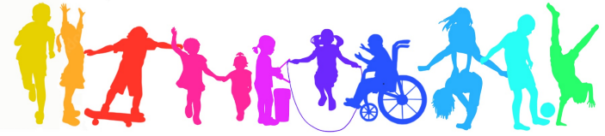Happy Creating ☺