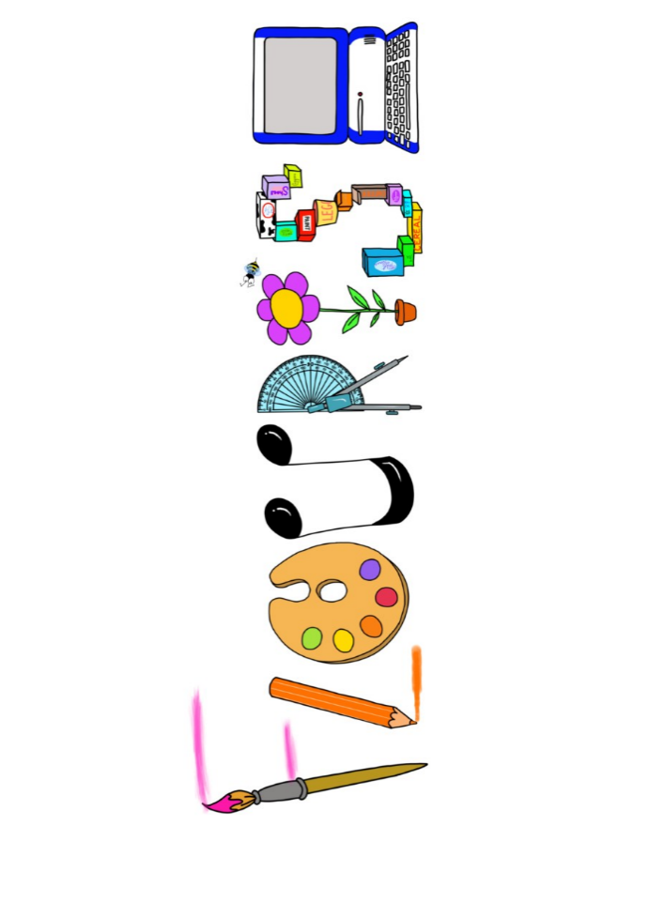 **at home.**

Penguins use your FLOURISH skills at home to create a masterpiece of your learning. Choose one task from the grid below.

|  |  |  |
| --- | --- | --- |
| **Term 2: Would you like to live in a world of darkness?** | | |
| **I enjoy writing creatively** | You are a caveman. Can you write a story about your daily life? | You have been given mammoth as a pet. Write a list of instructions on how to look after it. |
| **I enjoy learning about the world(geography, history, RE, languages)** | Visit a local Stone Age site. Write up your findings- what was there? | Create a 3D model of a globe. Showing how some countries have light whilst some don’t. |
| **I enjoy using technology** | Use an ipad or camera to create a stop motion of a stone age hunt. | Use scratch to produce a stone age moving picture. |
| **I enjoy being creative** | Can you create a picture called The Dark? | Invent your own Stone Age invention. Draw and label it. |
| **I enjoy being practical** | Make a Stone Age hunting tool. | Make something they may have eaten in the Stone Age. |

Your FLOURISH at home needs to be in school the week beginning **Monday 16th December 2024** . It will be shared☺ and celebrated☺.

Happy Creating ☺