
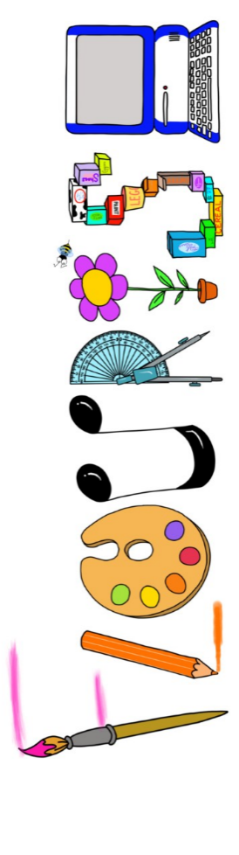 at home.
Kookaburras use your FLOURISH skills at home to create a masterpiece of your learning. Choose one task from the grid below.
Term 1: What makes me special?
I enjoy writing creatively | Make a book about your family. Can you include pictures and labels? | Draw and decorate your family tree.
I enjoy learning about the world(geography, history, RE, languages) | Find out about where you live? Can you draw your street or use google maps to print a picture? | Can you label the parts of the body in Spanish?
I enjoy using technology | Take some family photos and arrange them to make a collage. | Use a paint programme to create a self-portrait.
I enjoy being creative | Paint a picture of your favourite toy. | Can you make Boris the Robot out of junk material?
I enjoy being practical | Make a model of your house with lego or construction materials. | Make a skeleton picture using only cotton buds.


Your FLOURISH at home needs to be in school the week beginning Monday 19th October 2026 . It will be shared and celebrated.
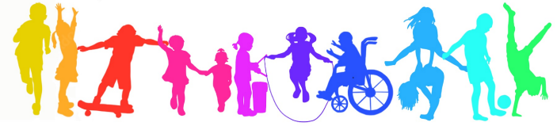
Happy Creating

