
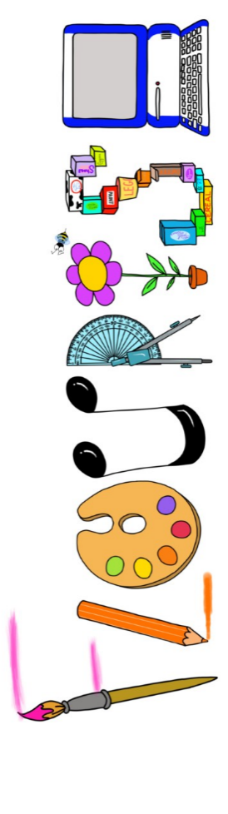 at home.
Hummingbirds use your FLOURISH skills at home to create a masterpiece of your learning. Choose one task from the grid below.
Term 1: Could a dinosaur live in our village?
I enjoy writing creatively | Create a dinosaur fact file on your favourite dinosaur. | Write a story a different ending to a story you have read in class.
I enjoy learning about the world(geography, history, RE, languages) | Locate on a map of Britain where fossils have been found? | Make a timeline of the dinosaurs. Include drawings if you can.
I enjoy using technology | Research Mary Anning and present how you like. | Visit the beach and take photos of any fossils you find.
I enjoy being creative | Invent your own dinosaur and paint a picture of it. | Create a pencil drawing of a fossil.
I enjoy being practical | Create a fossil using plasticine or clay. | Make a dinosaur out of junk model material.


Your FLOURISH at home needs to be in school the week beginning Monday 19th October 2026. It will be shared and celebrated.

Happy Creating

