
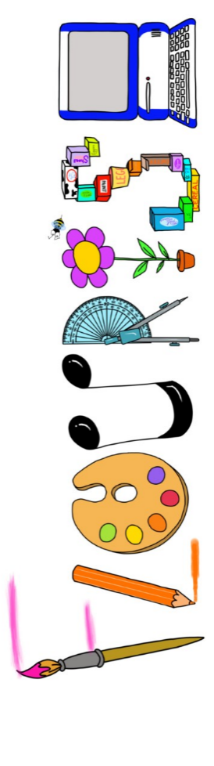 at home.
Penguins use your FLOURISH skills at home to create a masterpiece of your learning. Choose one task from the grid below.
Term 1: What would it be like to live in a world of darkness?
I enjoy writing creatively | You are a caveman. Can you write a story about your daily life? | You have been given mammoth as a pet. Write a list of instructions on how to look after it.
I enjoy learning about the world(geography, history, RE, languages) | Visit a local Stone Age site. Write up your findings- what was there? | Create a 3D model of a globe. Showing how some countries have light whilst some don’t.
I enjoy using technology | Use an ipad or camera to create a stop motion of a stone age hunt. | Use scratch to produce a stone age moving picture.
I enjoy being creative | Can you create a picture called The Dark? | Invent your own Stone Age invention. Draw and label it.
I enjoy being practical | Make a Stone Age hunting tool. | Make something they may have eaten in the Stone Age.


Your FLOURISH at home needs to be in school the week beginning Monday 19th October 2026 . It will be shared and celebrated.

Happy Creating

