
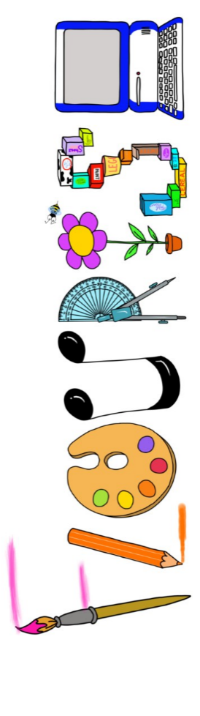 at home.
Kestrels use your FLOURISH skills at home to create a masterpiece of your learning. Choose one task from the grid below.
Term 1: What would it feel like to be in space?
I enjoy writing creatively | Write a story about a journey to space. Can you do it in 5 paragraphs? | Create either an acrostic or shape poem about space.
I enjoy learning about the world(geography, history, RE, languages) | Research a planet of your choice and present your findings. | Explain the Space Race- how creative can you be in showing your findings?
I enjoy using technology | Use scratch to create a rocket launch. | Make a photo diary of the moon over a period of time exploring differences in appearance.
I enjoy being creative | Create you own painting inspired the artist David Hardy. | Create an album cover for The Planets music by Holst.
I enjoy being practical | Use construction materials to make a rocket. | Create a model of the solar system.


Your FLOURISH at home needs to be in school the week beginning Monday 19th October 2026. It will be shared and celebrated.
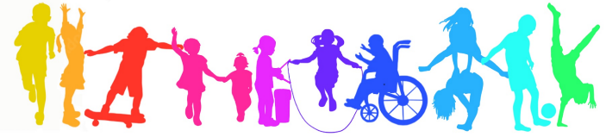
Happy Creating

