
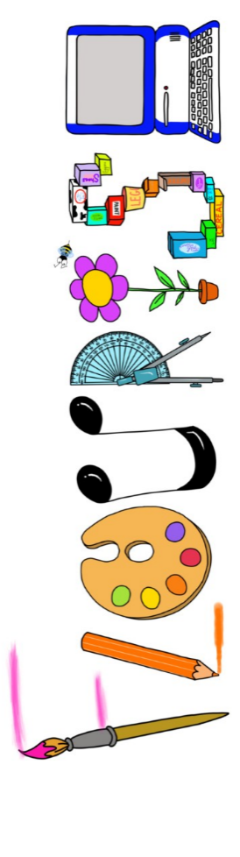 at home.
Kingfishers use your FLOURISH skills at home to create a masterpiece of your learning. Choose one task from the grid below.
Term 1 How will I survive?
I enjoy writing creatively | Create a manual for survival. | Create your own island setting description.
I enjoy learning about the world(geography, history, RE, languages) | Create your own theory about the demise of the Mayan civilisation. | You are a tour guide at Chichen Itza. What would be your top 5 sites to take your tour group to and why? What would you tell them?
I enjoy using technology | Use scratch to design an island survival game. (Google scratch)  http://scratch-kids.en.softonic.com | Create a video news report about Michael’s disappearance.
I enjoy being creative | Design your own Mayan head dress in the style of a Mayan god or goddess. | Create your own artwork inspired by Jerry Clovis
I enjoy being practical | Create an animal trapping device. | Design and build an island that you could live on.


Your FLOURISH at home needs to be in school the week beginning Monday 19th October. It will be shared and celebrated.

Happy Creating

